Day 32
12.9.2025
Task 1:
Create table in Cynamo DB using Java
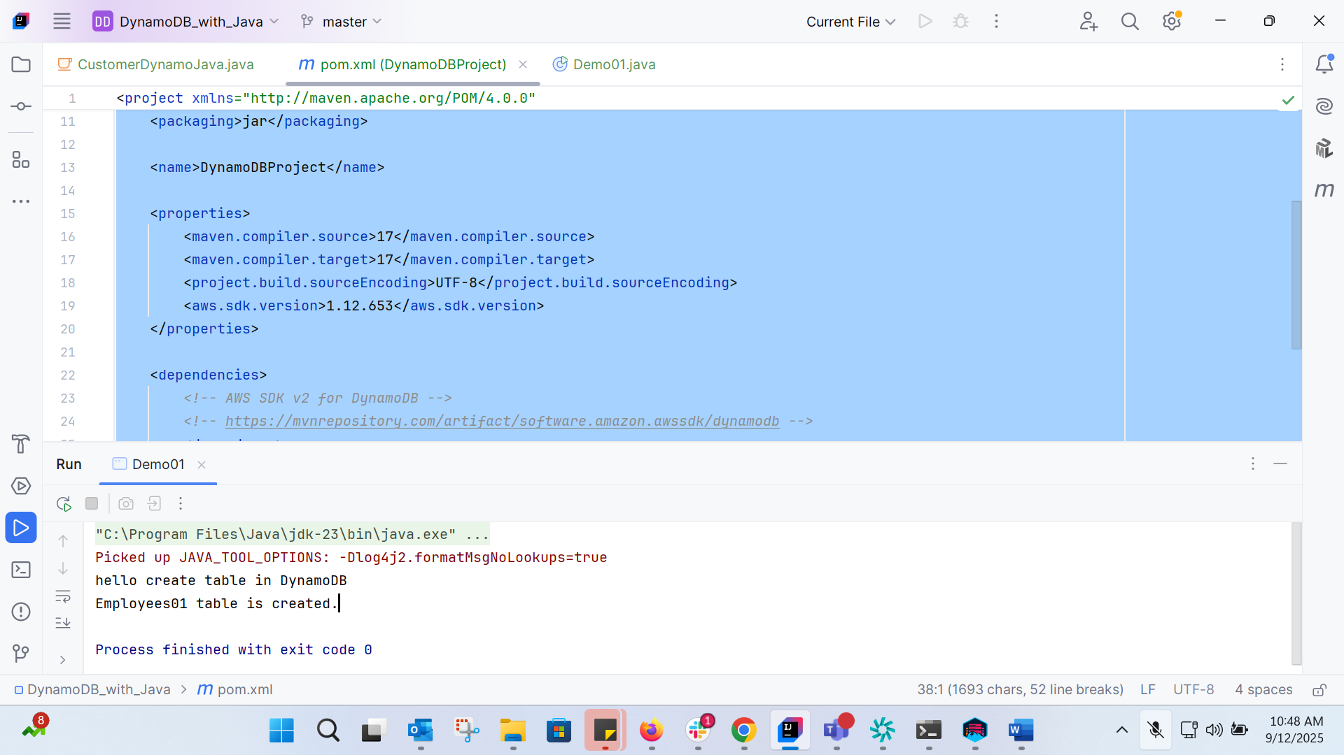
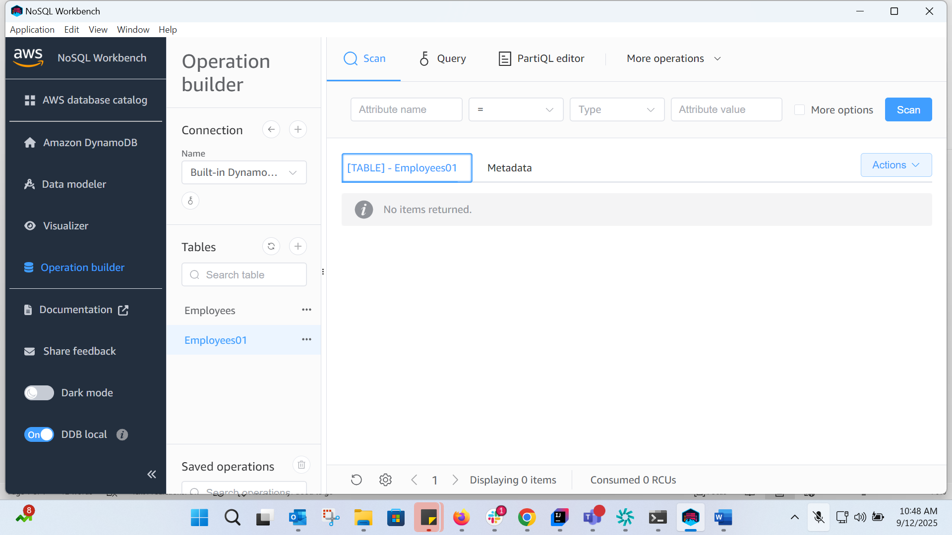
Task 3:
For the same above tables see the description of the tables..
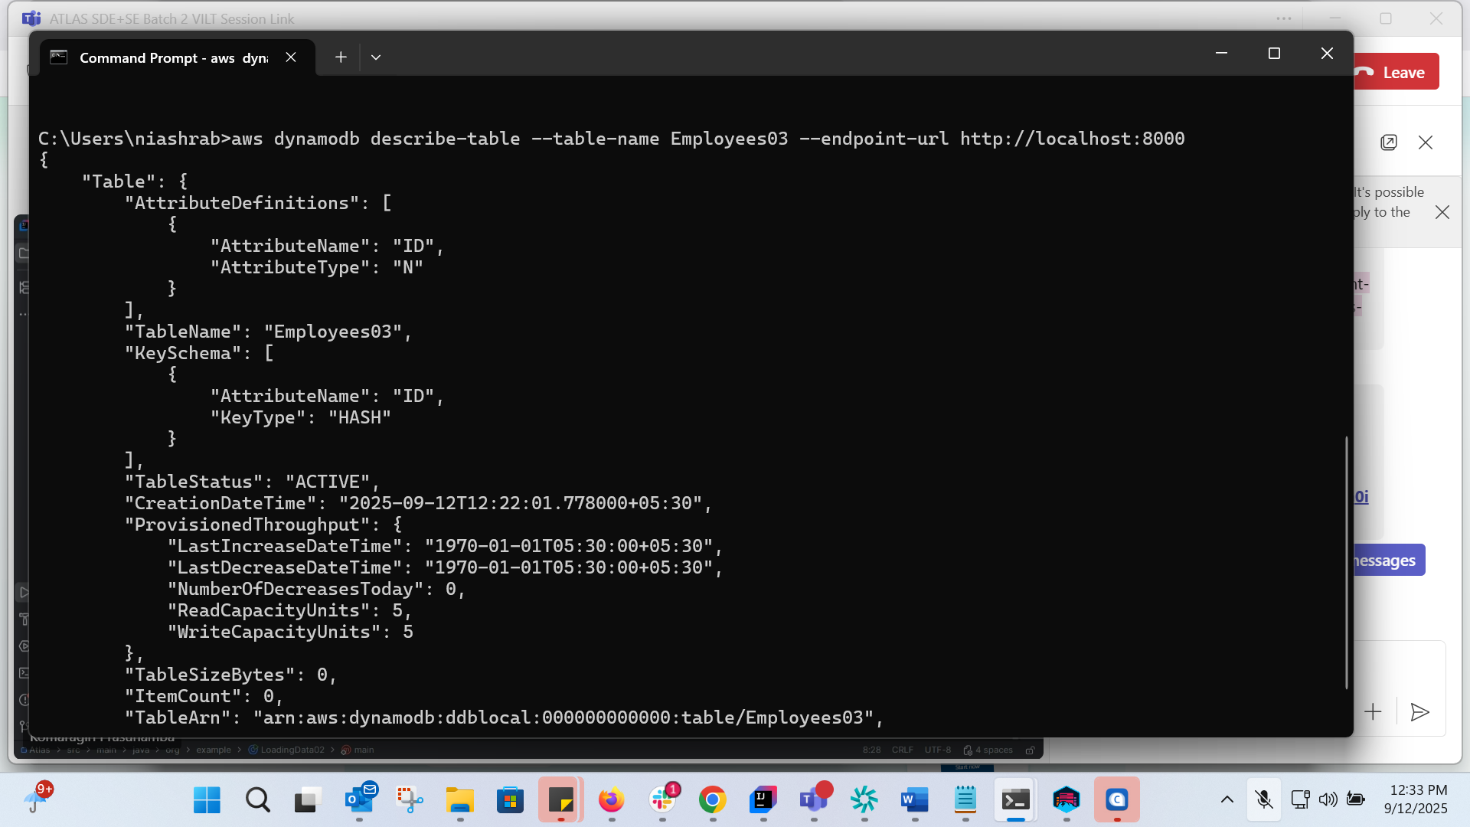
Task 4:

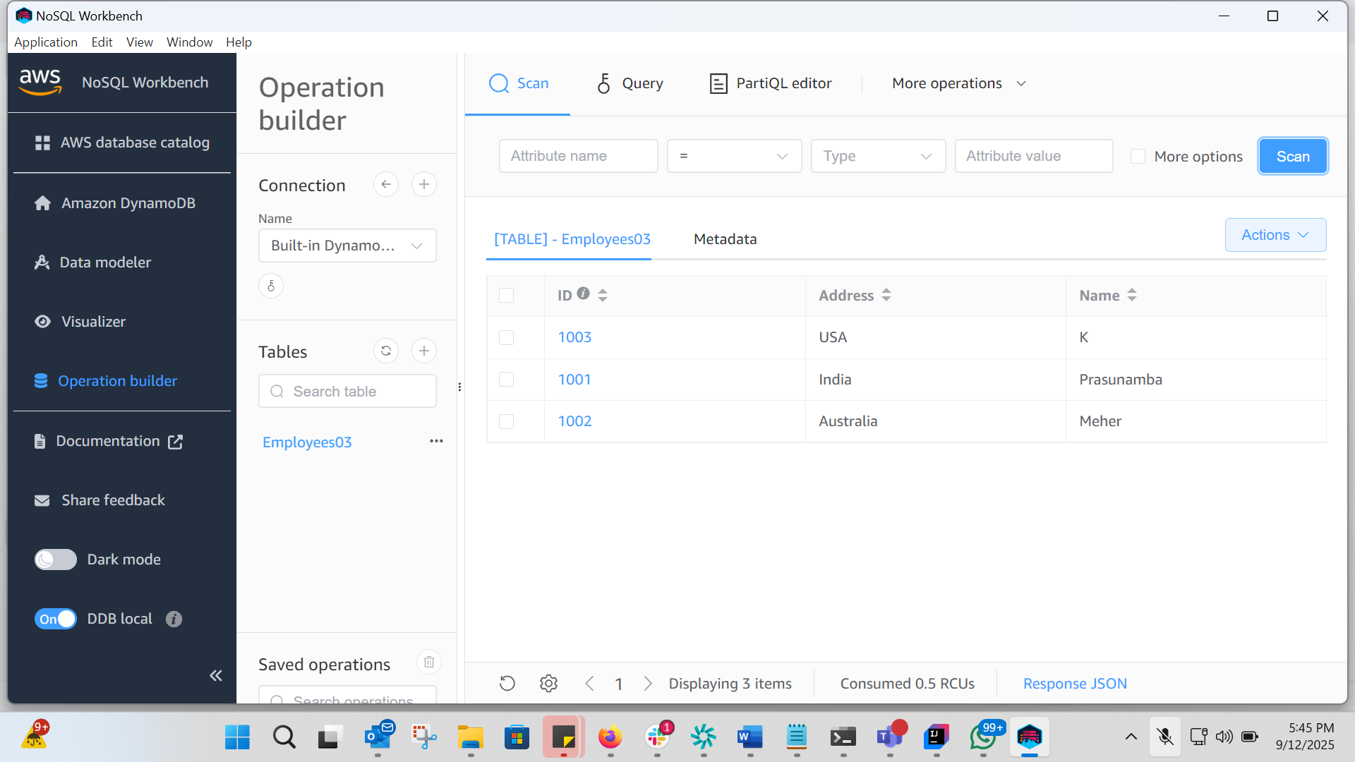
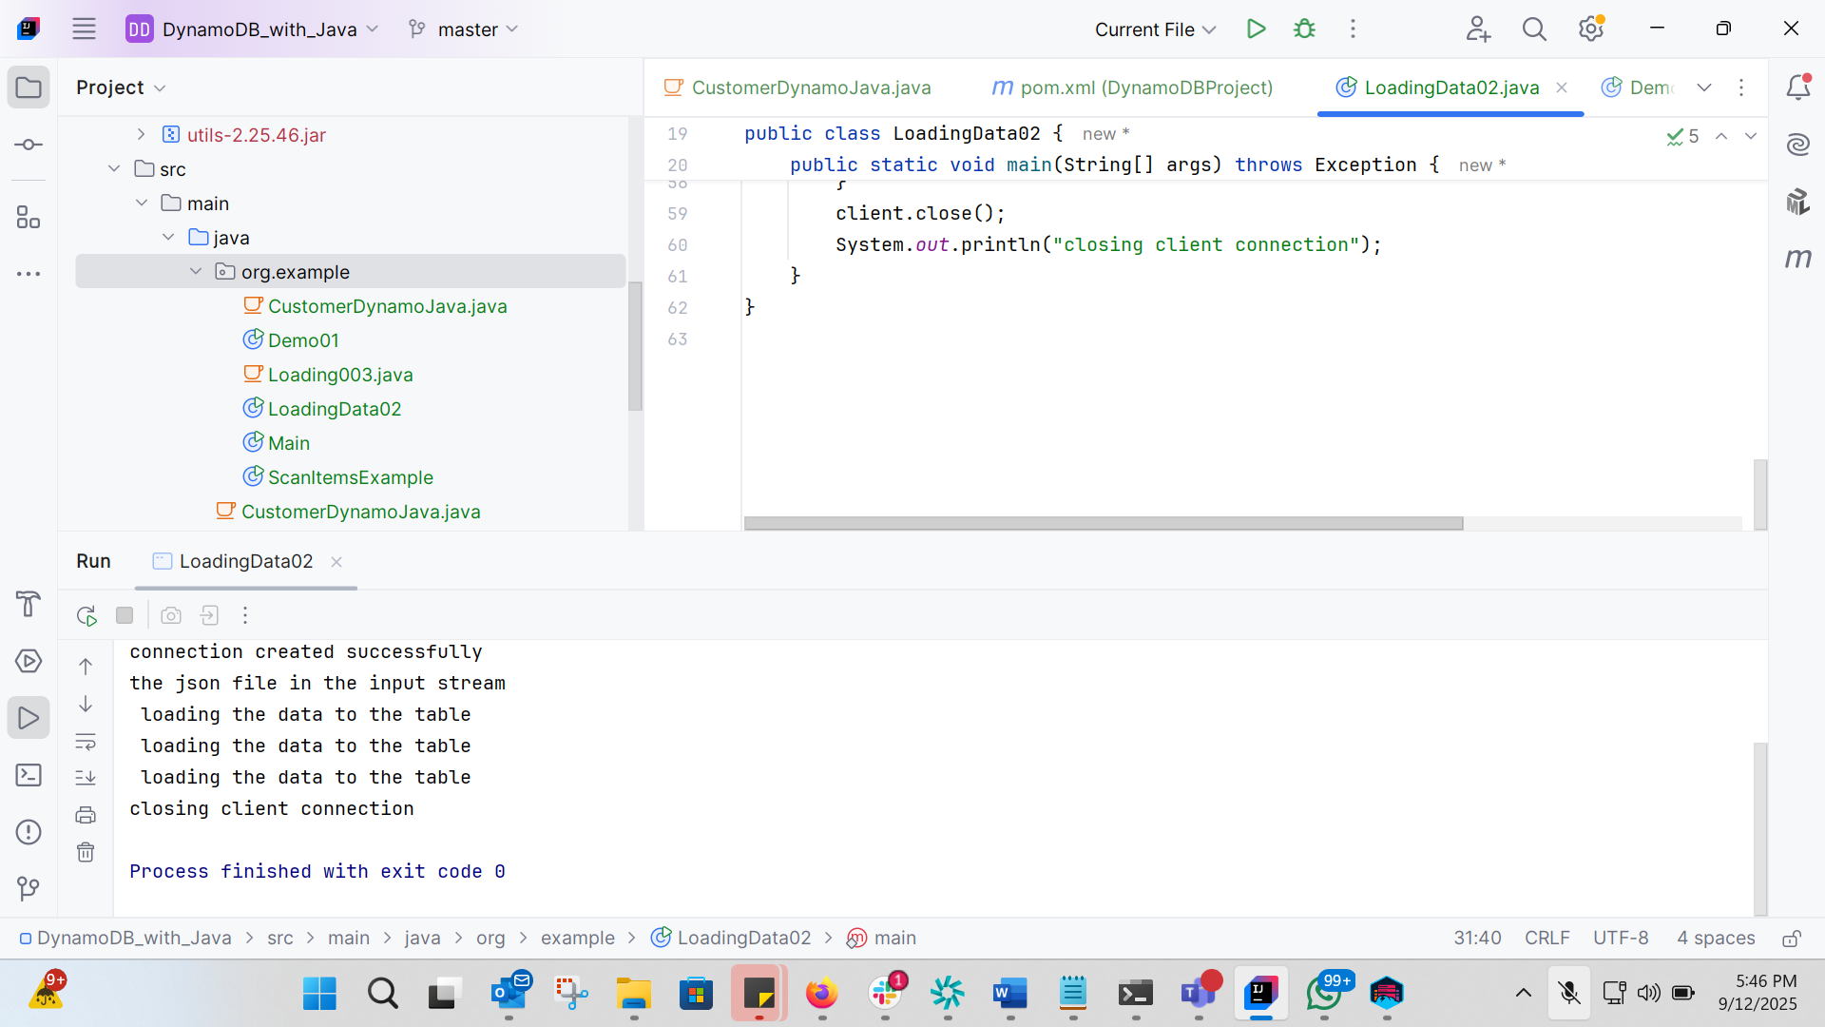
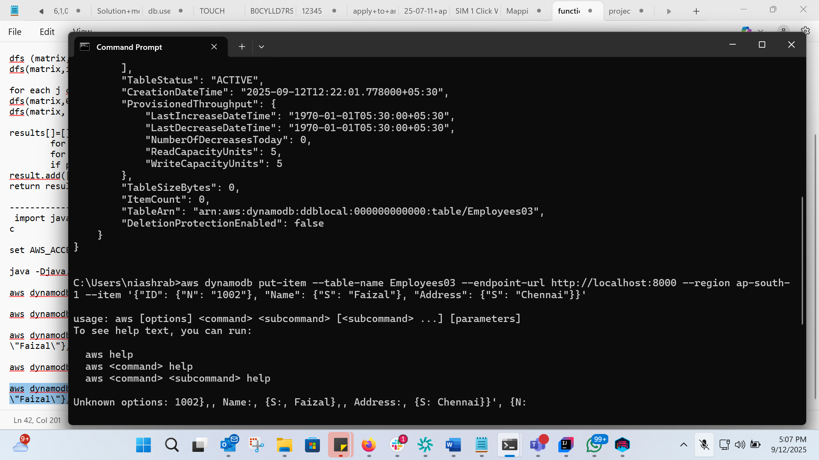
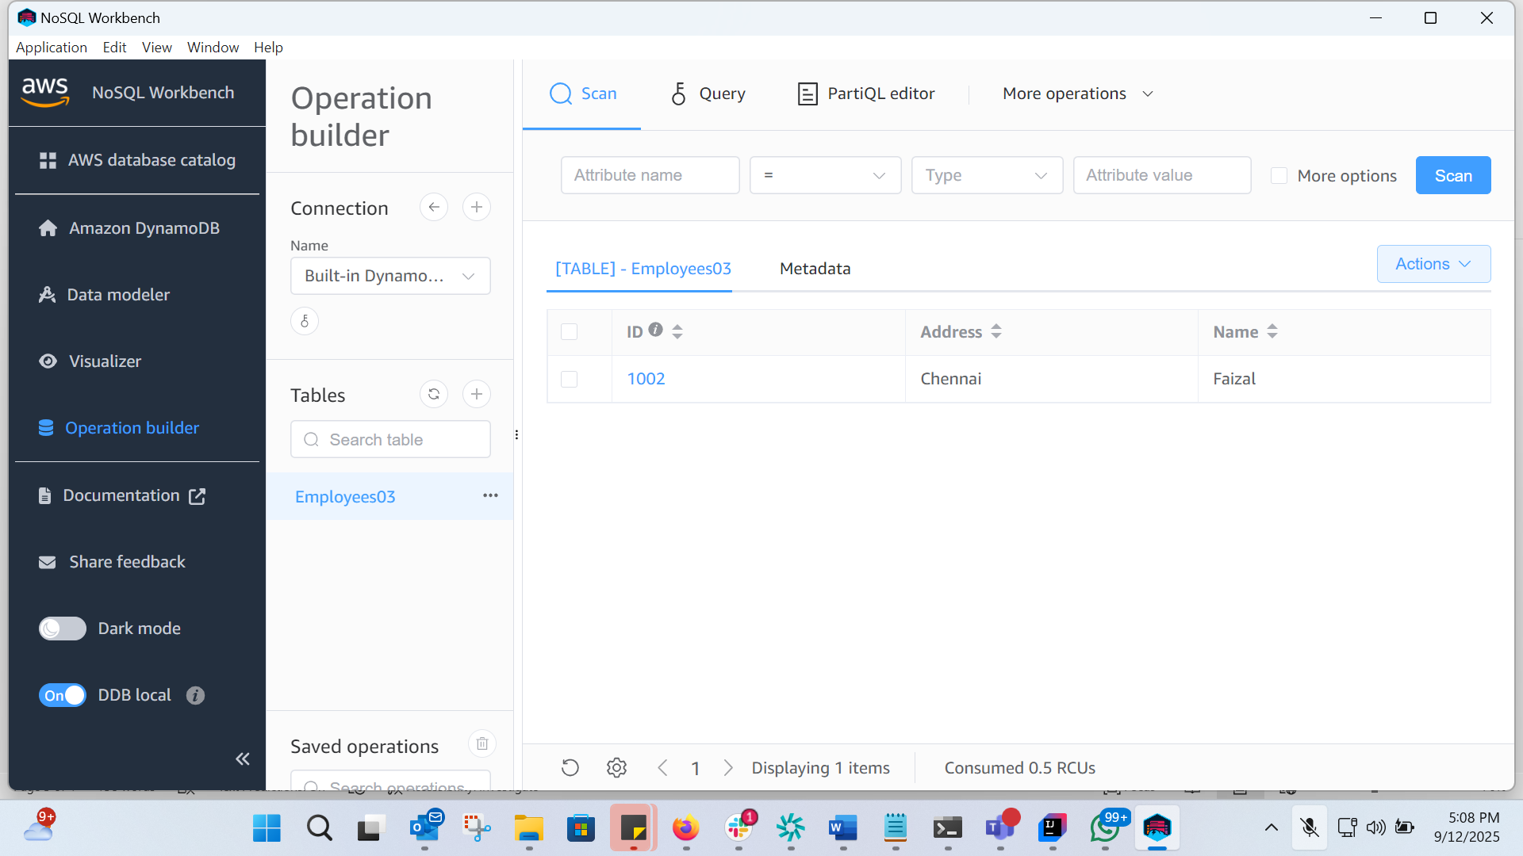
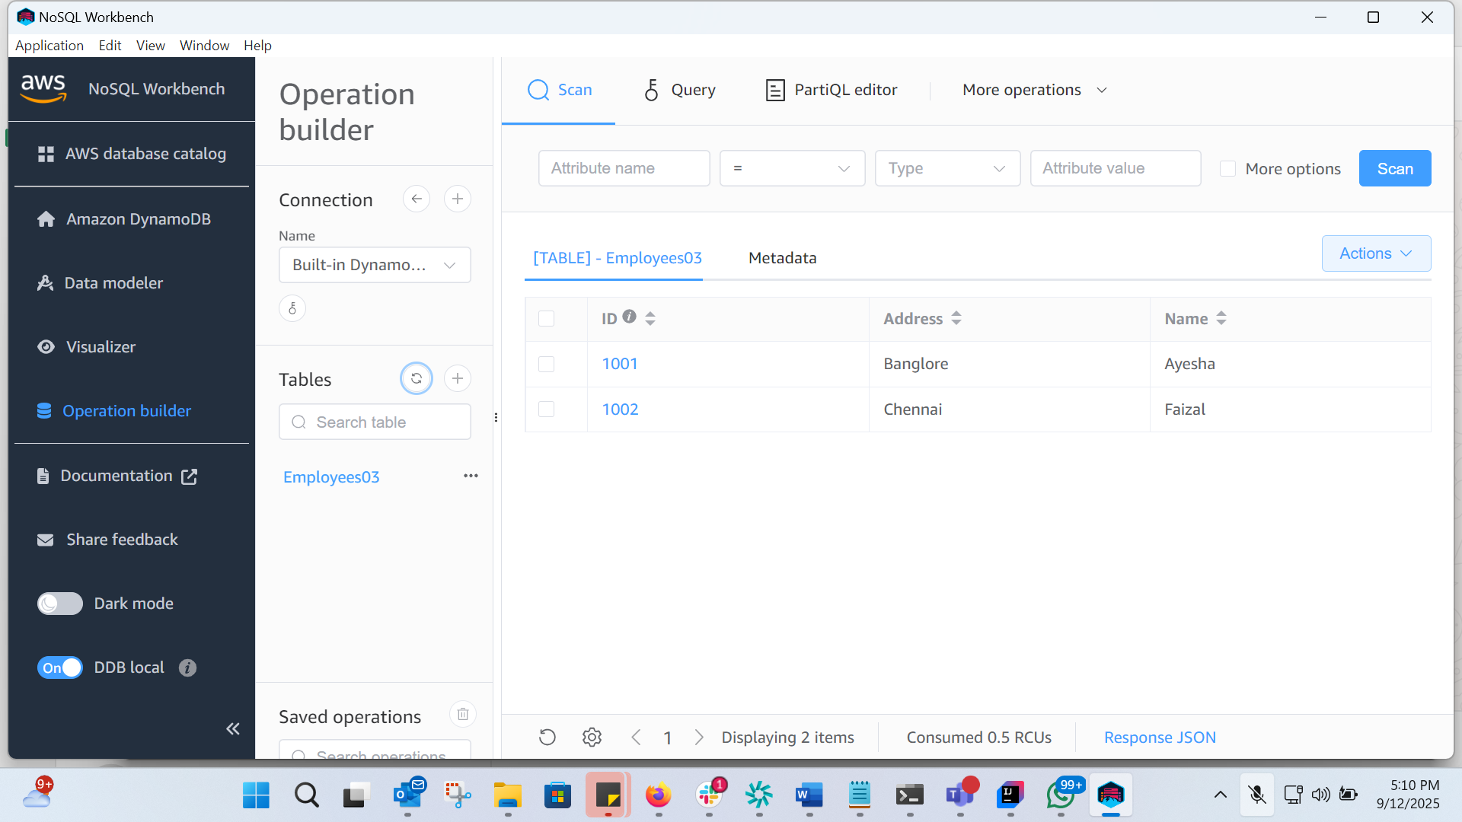

Task 05:

Reading / Scanning the data from the server.. Using java code..
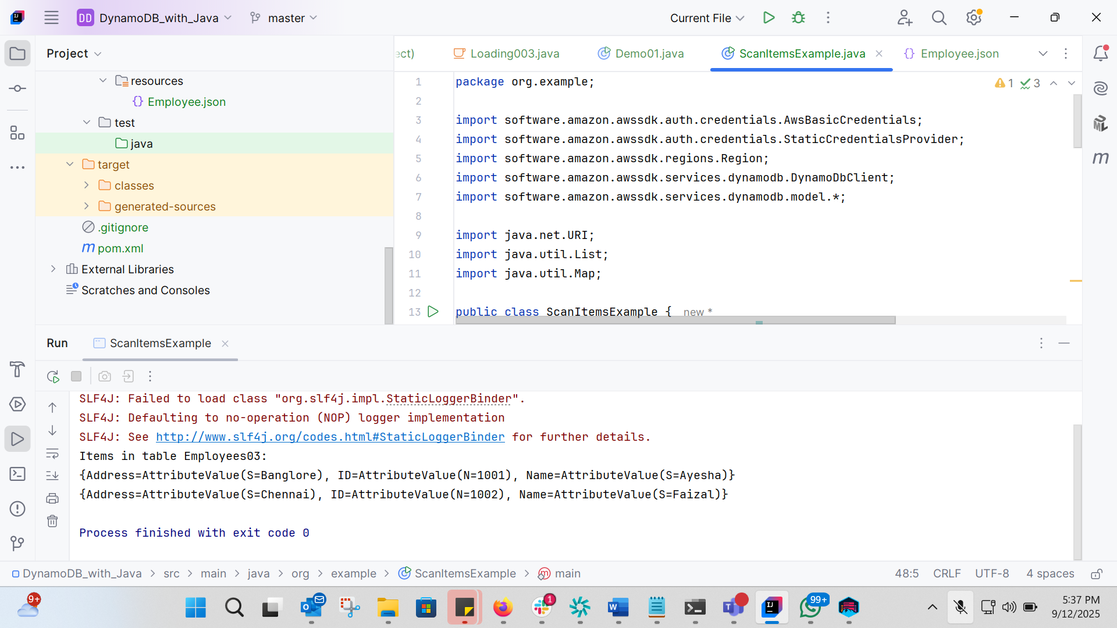
Task 06:

Insert an item in the nosql workbench.. And check if the item reflects in your java output…
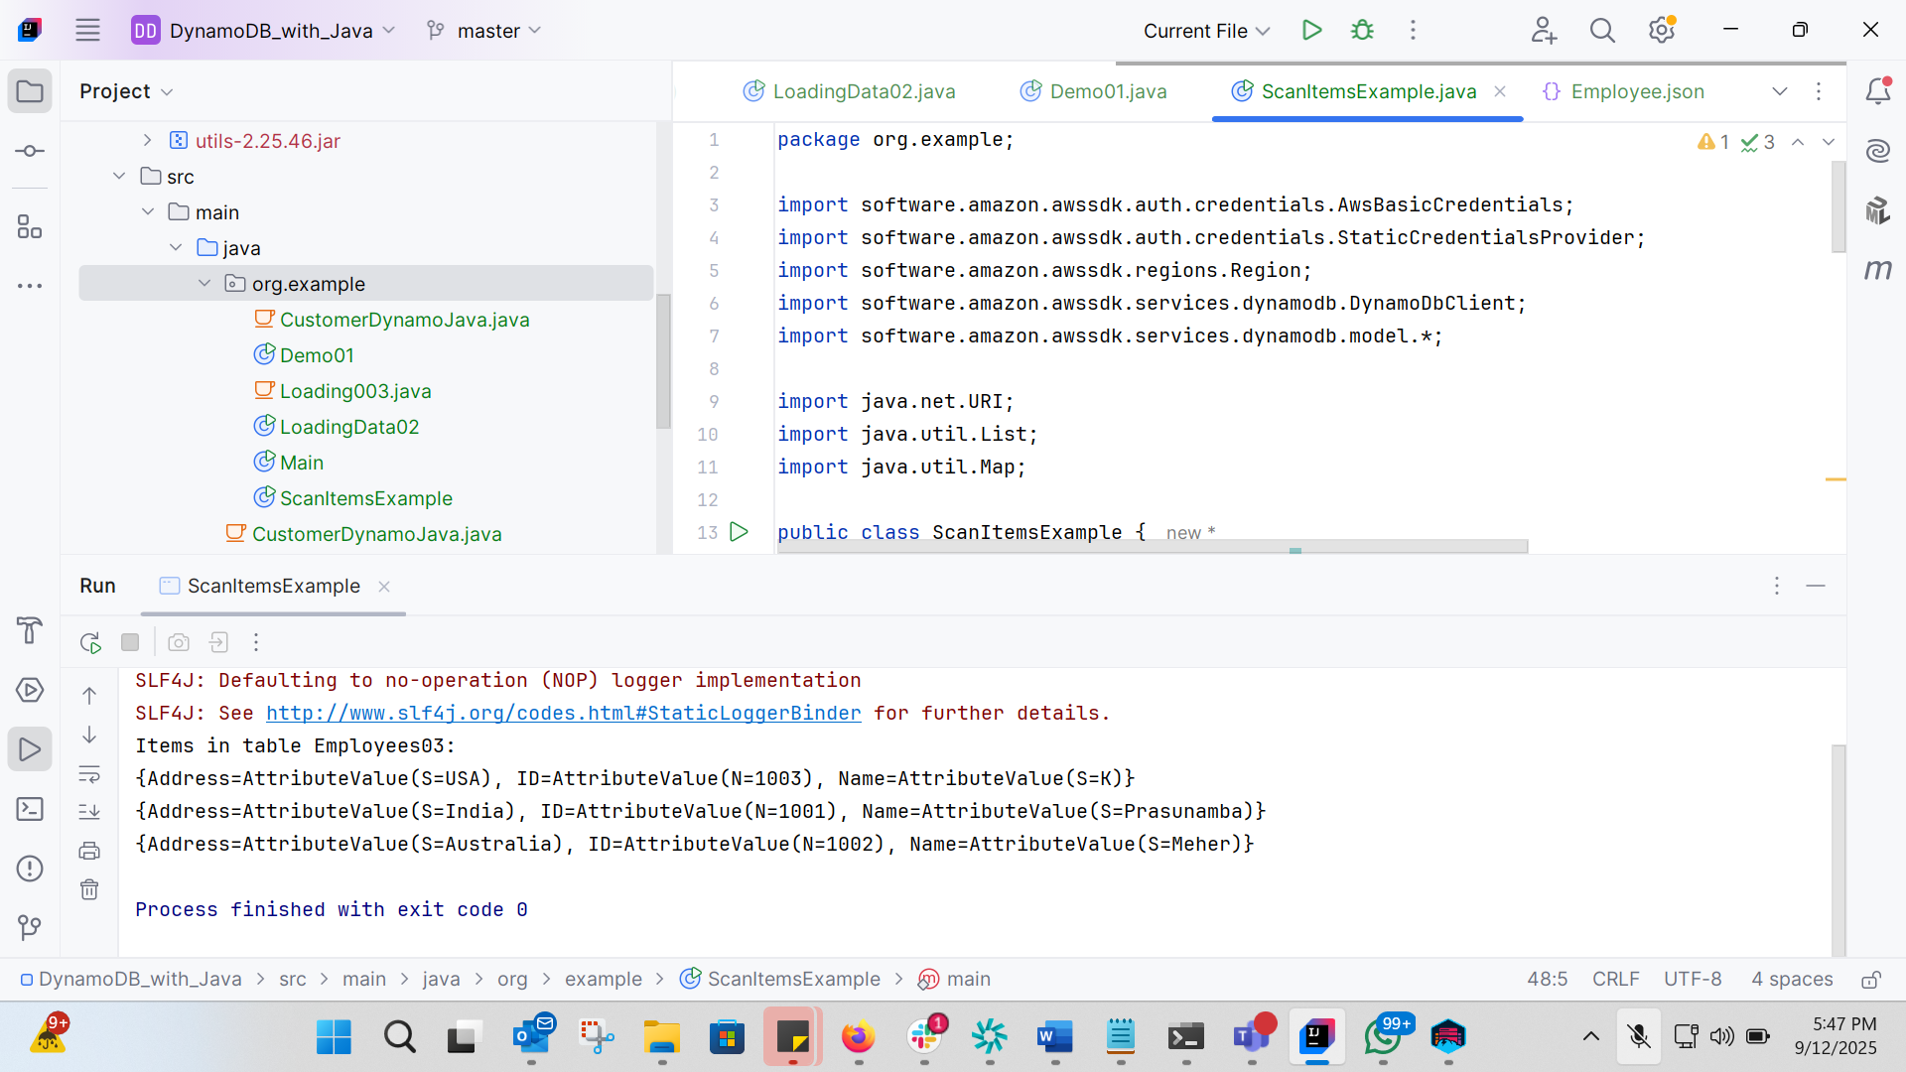
Task 07:

How do you lower the cost of DynomaDB..explain ways to do so…
To lower DynamoDB cost:
Use the right billing mode (On-Demand vs Provisioned with Auto Scaling).
Prefer Query over Scan and fetch only required attributes.
Use eventual consistency, batch operations, and caching (DAX) to reduce RCUs/WCUs.
Keep items small, limit GSIs, and enable TTL to auto-delete old data.
For steady workloads, use Reserved Capacity/Savings Plans.
Task 08:

Update item details using java code.. And check if it reflects in the server..
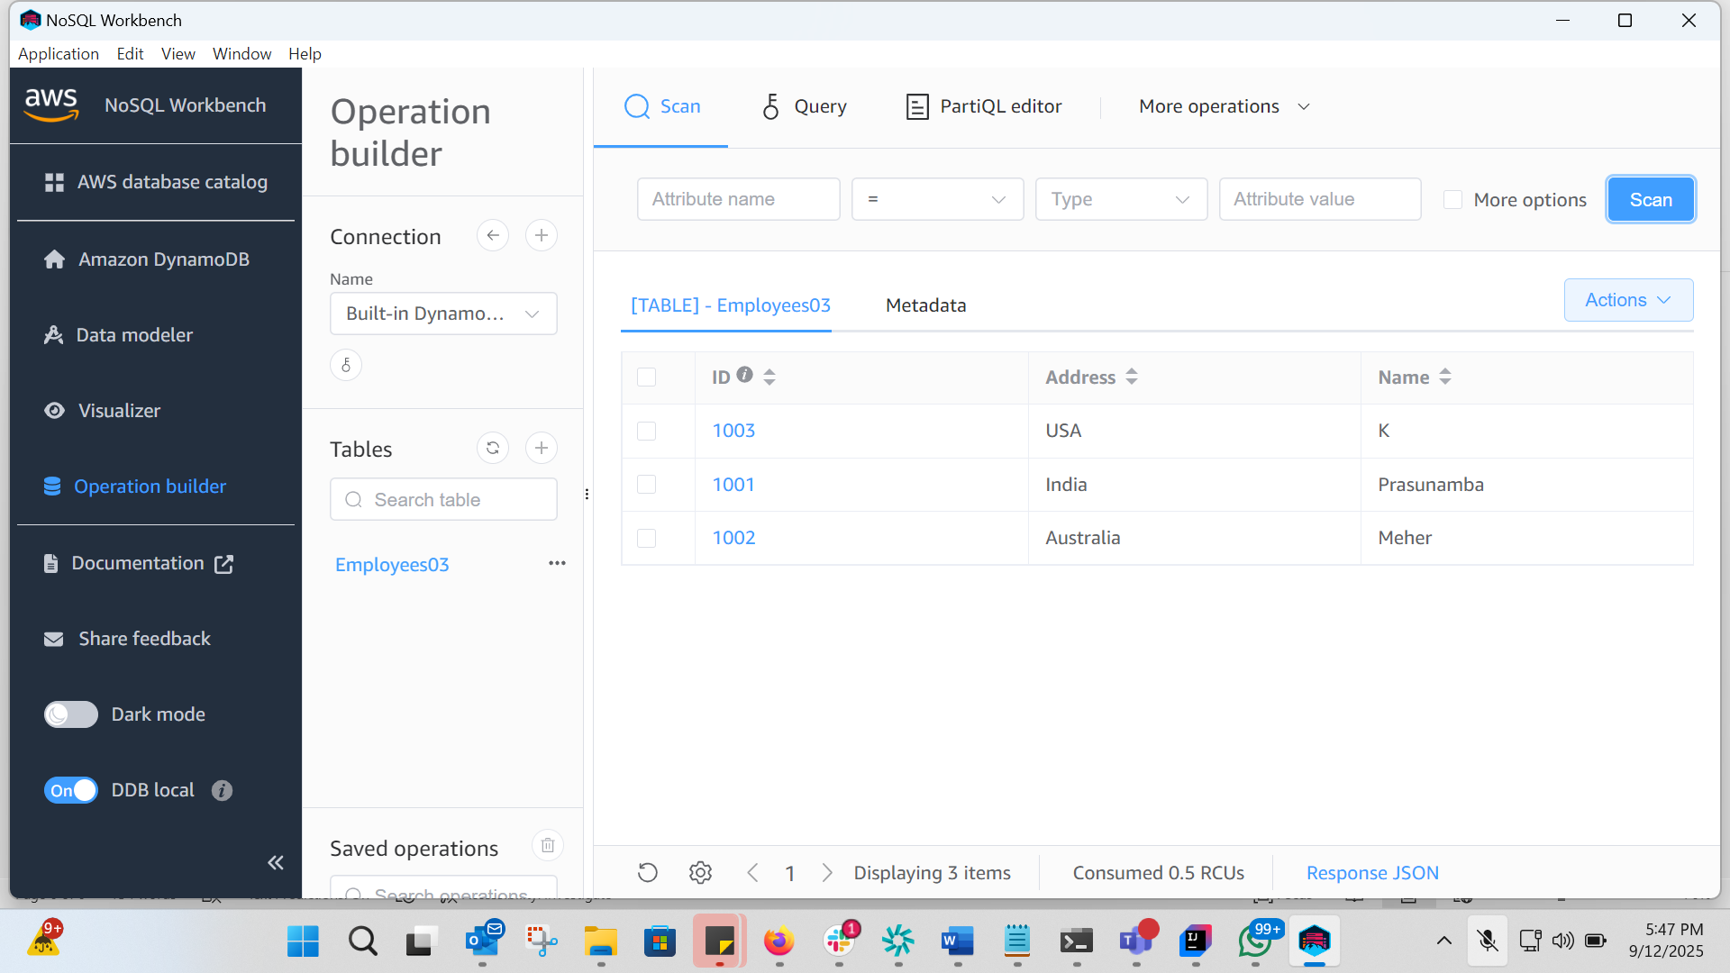
Task 09:

Delete a particular item from the table …
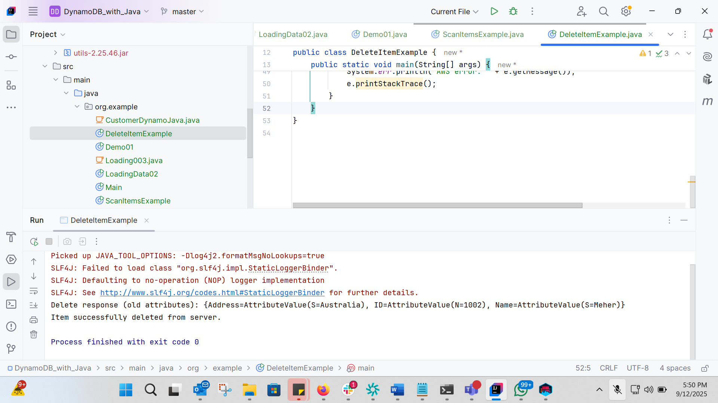
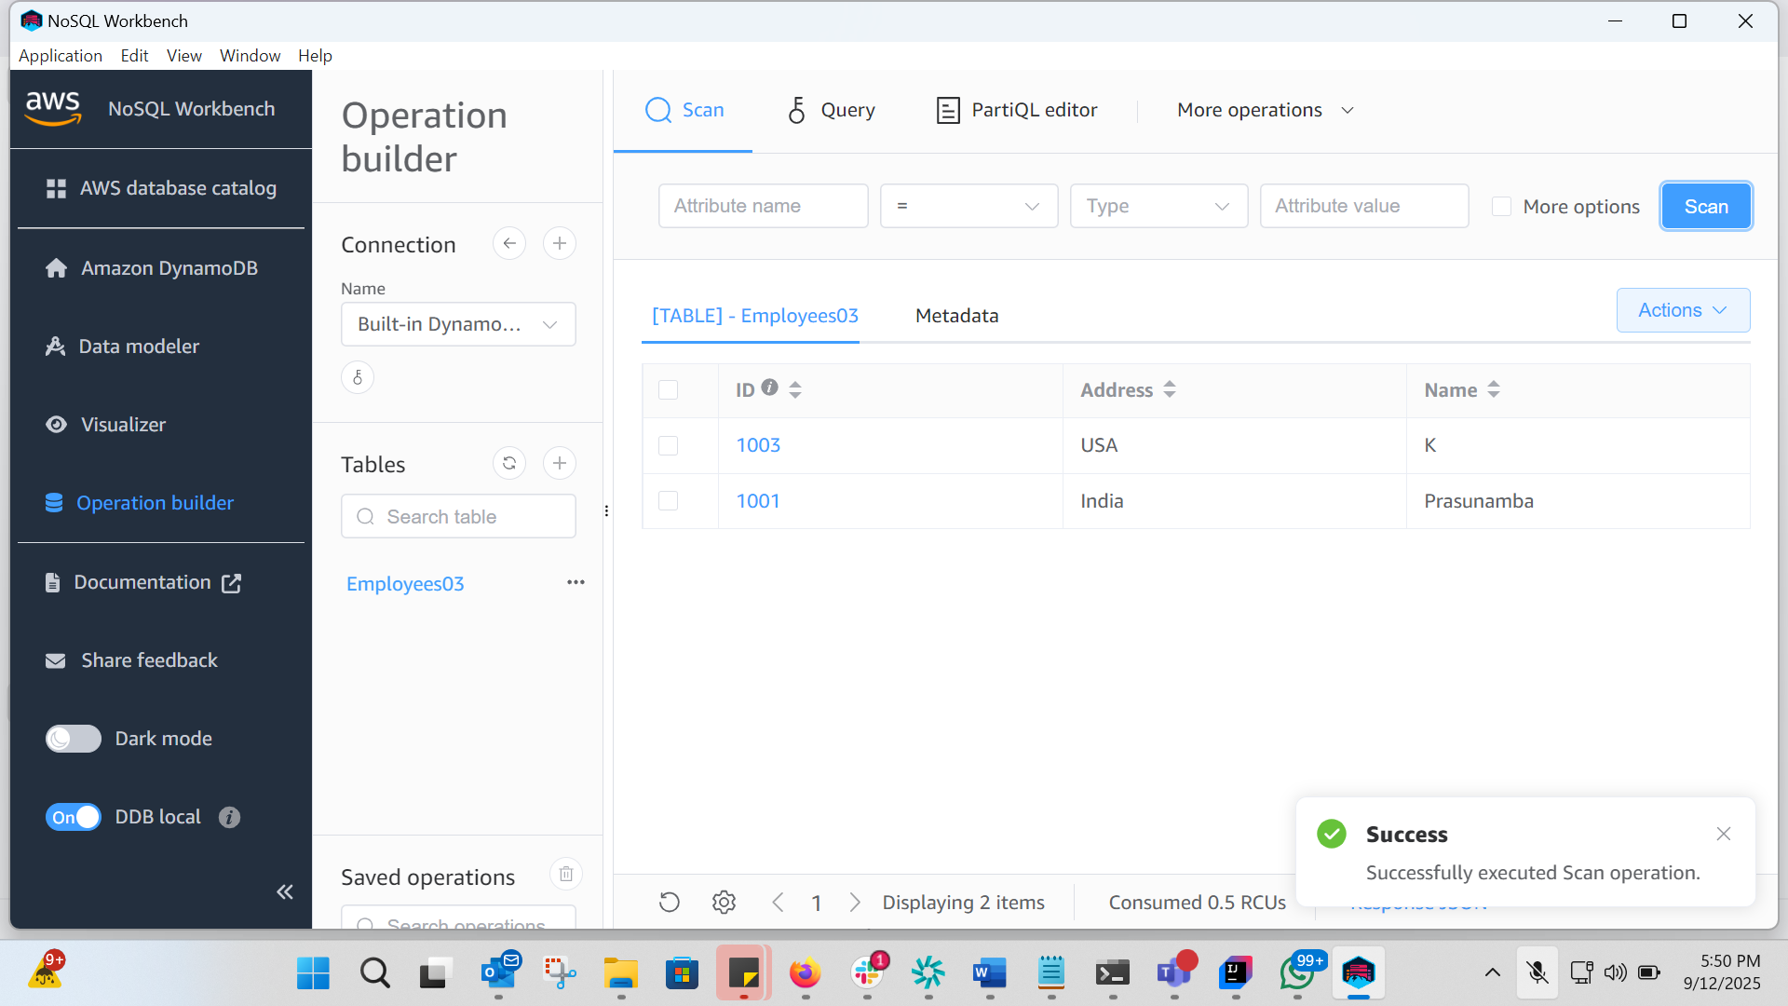

DAX -

